Mid Term Test
MATLAB

- a) Create an anonymous function for and use it to graph the interval 0 ≤ x ≤ 2.

  - Create an anonymous function of and use it to draw the function for the interval 0 ≤ x ≤ 0.2, with the step 0.01 and find where the f(x)=0 is approximated.

  - Use the “fzero” function to accurately find the position of the f(x)=0 of the function in (b).

x=0:0.01:0.2;
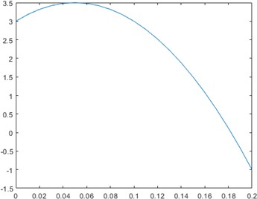

y=(20.*x)-200.*(x.^2)+3;

plot(x,y)

- The table below shows the hourly wages, worked hours, and output (number of products) for five product operators (產品作業員) in a week.
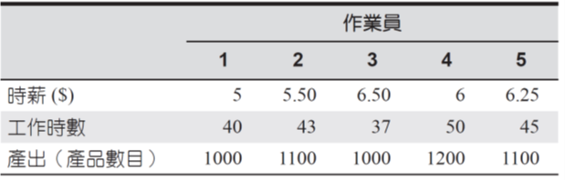

Use MATLAB to answer the following questions:

- How much salary did each worker earn this week?

- What is the total salary paid?

- How many units are manufactured?

- What is the average cost per unit of output?

- How many hours does it take on average to produce a product?

- Assuming that each operator produces the same quality product, which operator is the most efficient? And which one is the most inefficient?

- A fenced enclosed area consists of a rectangle of length L and width 2R, and a semicircle of radius R, as shown in Figure P.4. The area A of this enclosed area is 2000 square feet. Fence costs $50 per foot for curved sections and
$40 per foot for straight sections. Use the “fminsearch” function to determine R and L that minimize the cost of fencing at a resolution of 0.01 feet. Also calculate the minimum cost
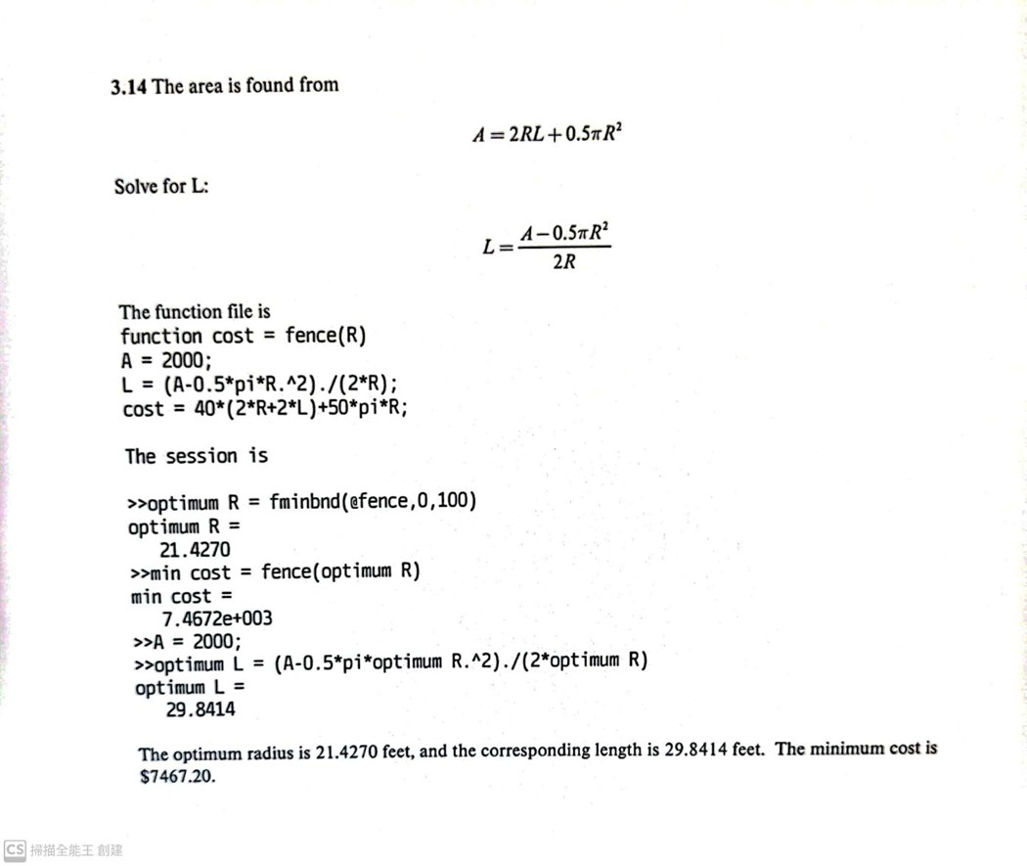

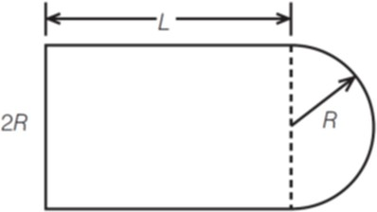

- Write a MATLAB SUB-function (*.m) to evaluate the members of the sequence,
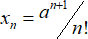

where a, and n are the inputs and the sequence value of is the output of this SUB-function and save it as a script file. Then, write a main function to input the range of the value n from 0 to 20, and =2, and call the SUB-function to evaluate the sequence value, and display the value of n and by using “fprintf”, as the following format:

n
0 | 2
1 | 4
2 | 4
3 | 8/3

- In MATLAB, input the following matrix, and use this matrix to answer the following questions.
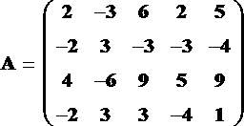

- Construct a 4x3 matrix B, its elements is the third column through 5th column of A
- Construct a 2x5 matrix C, its elements is the second row through 4th row of A
- Construct 2×3 matrix D, its elements is the first two rows and the last three columns of A

6.
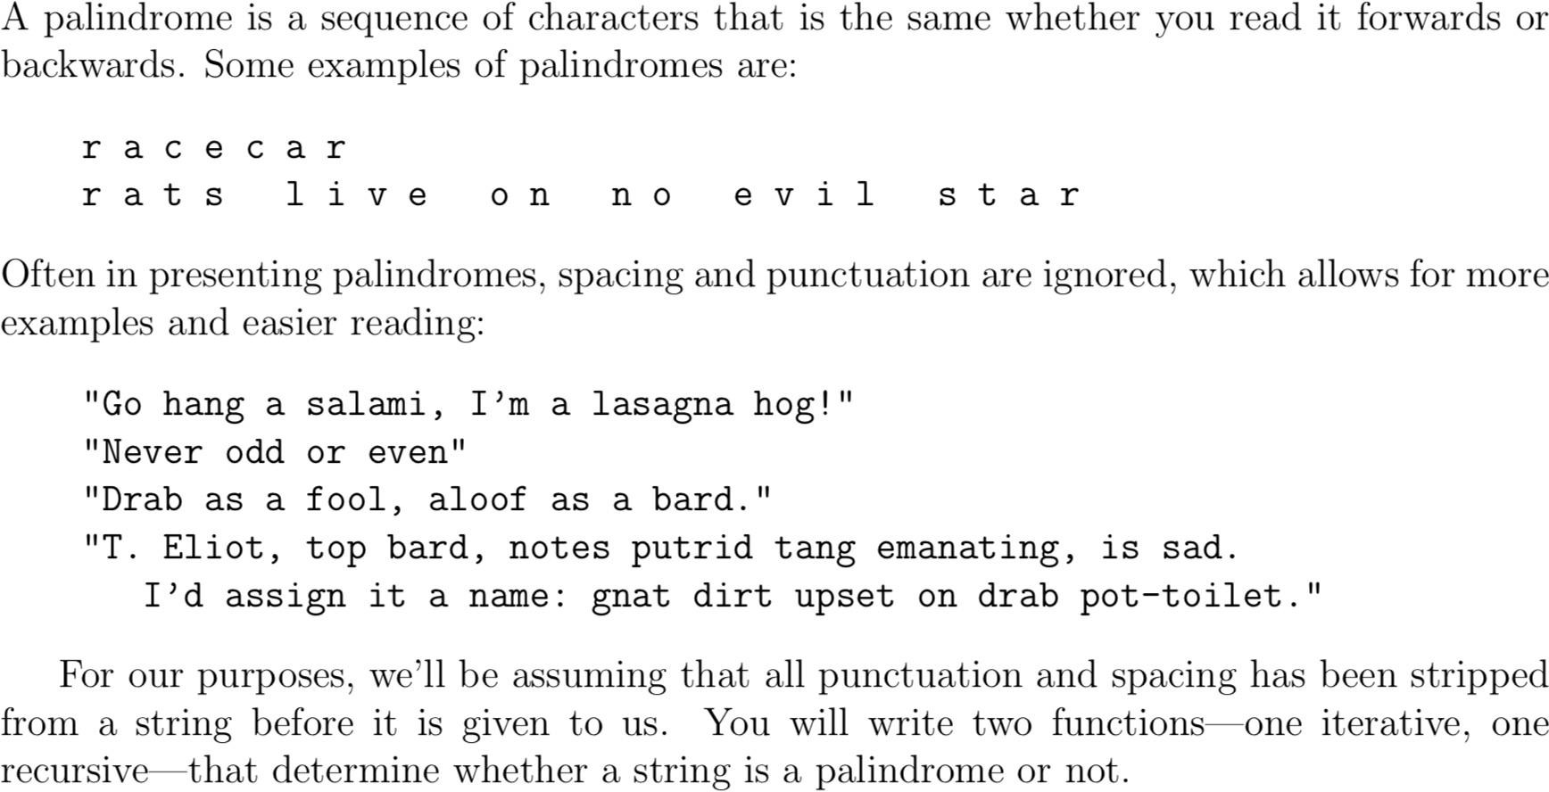

Write a recursive function to check a palindrome. function is_pal = pal1(str)

